**SMART WATER SYSTEM**

**OBJECTIVE :**

The IoT-Based Real-Time Water Consumption Monitoring project presents an innovative and impactful solution to address the pressing issue of water conservation in public spaces, particularly parks and gardens. In many regions, the unsustainable use of water resources poses a significant environmental challenge. To combat this issue, our project leverages the power of IoT technology to develop a comprehensive system that monitors water consumption in real-time. By making this vital information accessible to the public and relevant stakeholders, we aim to drive awareness, promote responsible water usage, and ultimately contribute to the preservation of our precious water resources .This initiative reflects our commitment to sustainability and a brighter, water-efficient future.

**BLOCK DIAGRAM:**

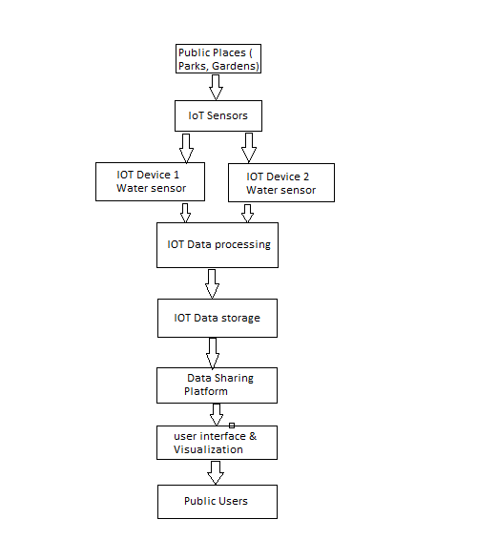

It represents the design and deployment of IoT sensors to monitor water consumption in public places.

1. **Public Places**: The locations where you'll install the IoT sensors, such as parks and gardens.
2. **IoT Sensors**: These sensors (IoT devices) are responsible for monitoring water consumption. They collect data and transmit it to the IoT data processing component.
3. **IoT Data Processing**: This component processes and validates the data received from the sensors before storing it.
4. **IoT Data Storage**: Data is stored securely, ensuring its availability for analysis and retrieval.
5. **Data Sharing Platform**: This platform provides access to real-time water consumption data through a user-friendly interface.
6. **User Interface & Visualization**: The interface where public users can access and visualize water consumption data. This could be a web application or a mobile app.
7. **Public Users**: The end-users, which can include the general public, park authorities, or environmental organizations.

We use the ESP8266 ,flow sensor, Ultrasonic Distance Sensors, Water Level Sensors, Water Quality Sensors etc…

**INTEGRATION APPROACH :**

The IoT sensors in our project will send data to the data-sharing platform through a secure and efficient process. These sensors, placed in public areas, will collect water consumption data and transmit it using established communication protocols over the internet or wireless networks. Once received, the data will be processed and made available to the public through a cloud-based platform. Strong security measures will protect the data during transmission, ensuring its accuracy and privacy. This system enables real-time monitoring of water usage and promotes water conservation by providing accessible data to the community

**CONCLUTION:**

This project presents a valuable solution for promoting water conservation in public spaces through the use of IoT technology. By implementing sensors to monitor real-time water consumption and sharing this data publicly, we aim to raise awareness, encourage responsible water usage, and contributeto thesustainable management of our precious water resources.